Report Week 4

Achievements:
- Established a simple protocol for writing data to each and every core.
The smallest unit of data is a 4-byte integer. Every string data entry has to be
converted into 4 integers, where every integer stores 4 characters (8-bit each).
The main purpose of this format is to simplify memory allocation, albeit
at the expense of speed when loading data, since strings have to be converted to
integers first
Note: By default, strings are not allowed to have more than 16 characters (for now)
Details of the data protocol can be seen in image 1 and 2.

Goals for next week:
- Implementing edges to enable communication structures between cores
- Once edges between cores are available, the first testing algorithm will be
implemented
- Image 3 shows a possible core structure for accessing data and returning results
- Image 4 proposes an algorithm (count the number of data entries) for testing the
connections. Potential problems, such as spike overload, can thus be detected early
on. Furthermore, the result is already known before the computation, since we as
the users know already from the beginning how many data entries we allocate to
each core

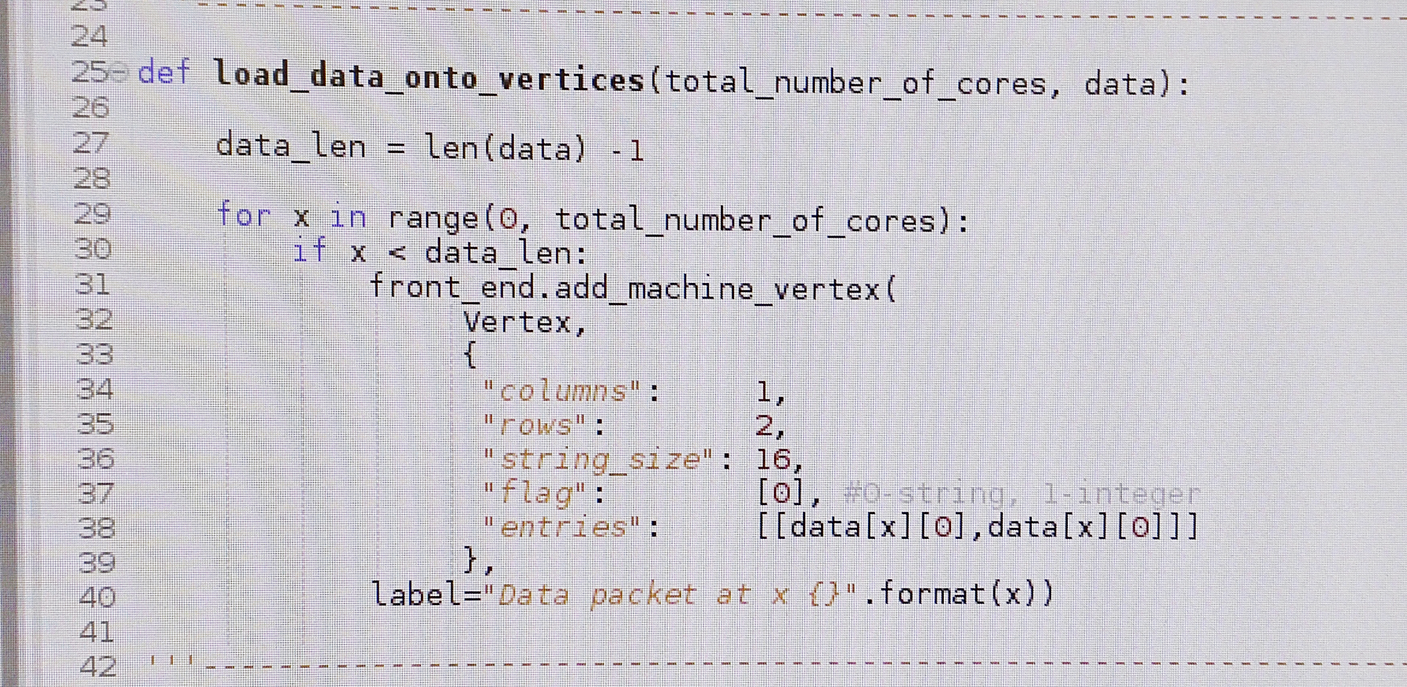
Image 1 & 2

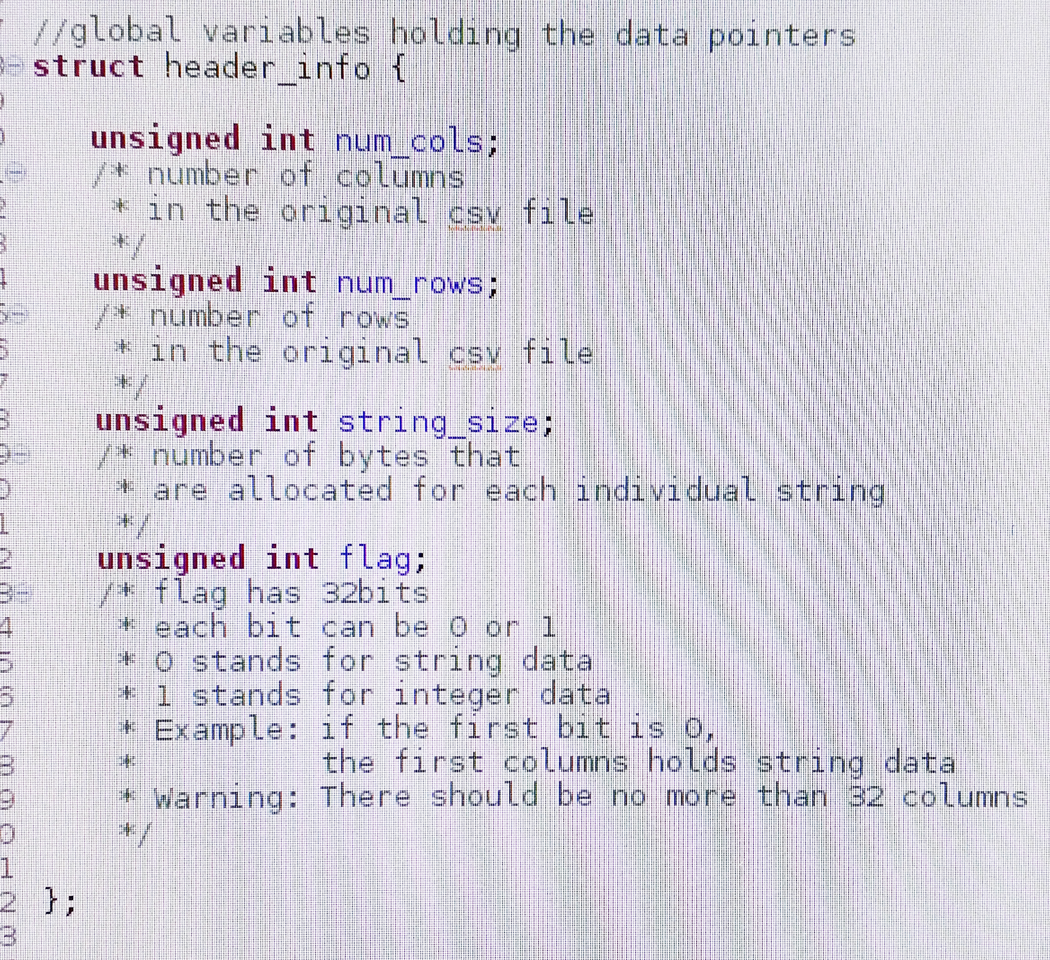
Image 3

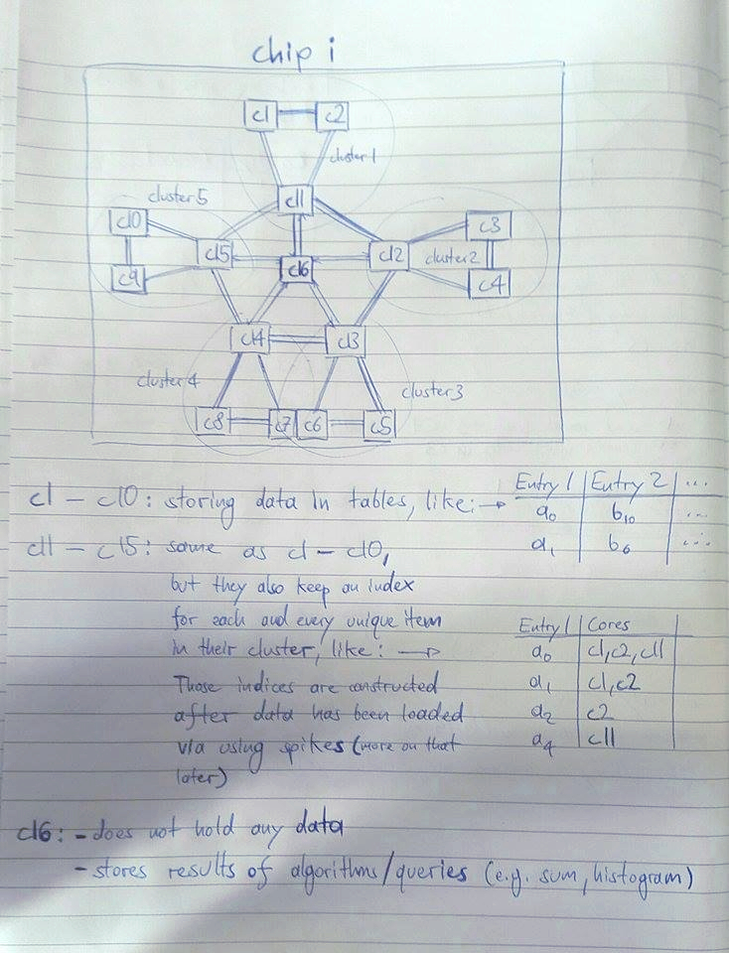

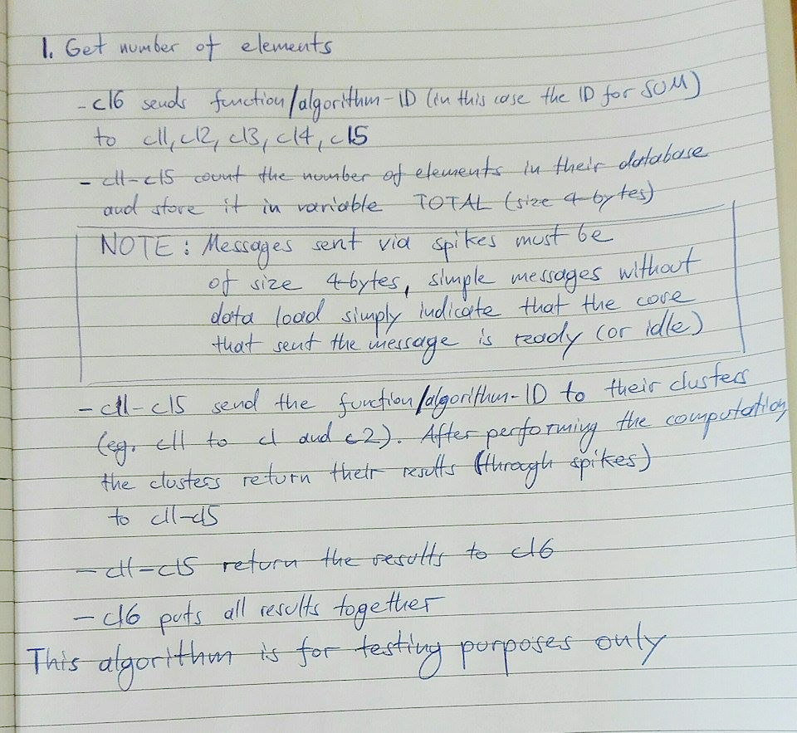
Image 4

